Okay, I'm leaving this assignment really open-ended. If you're thinking about an app, choose the option that best fits the layout you'll be working towards.

You can implement an ActionBar, ToolBar or sliding drawer navigation.

Provide at least 3 links in the navigation to another activity.

Describe what type of navigation you implemented and why you chose it.

Describe any challenges that you encountered when implementing it.

When complete, please upload a Word document with screenshots of your code and the app running.

15 Points Total

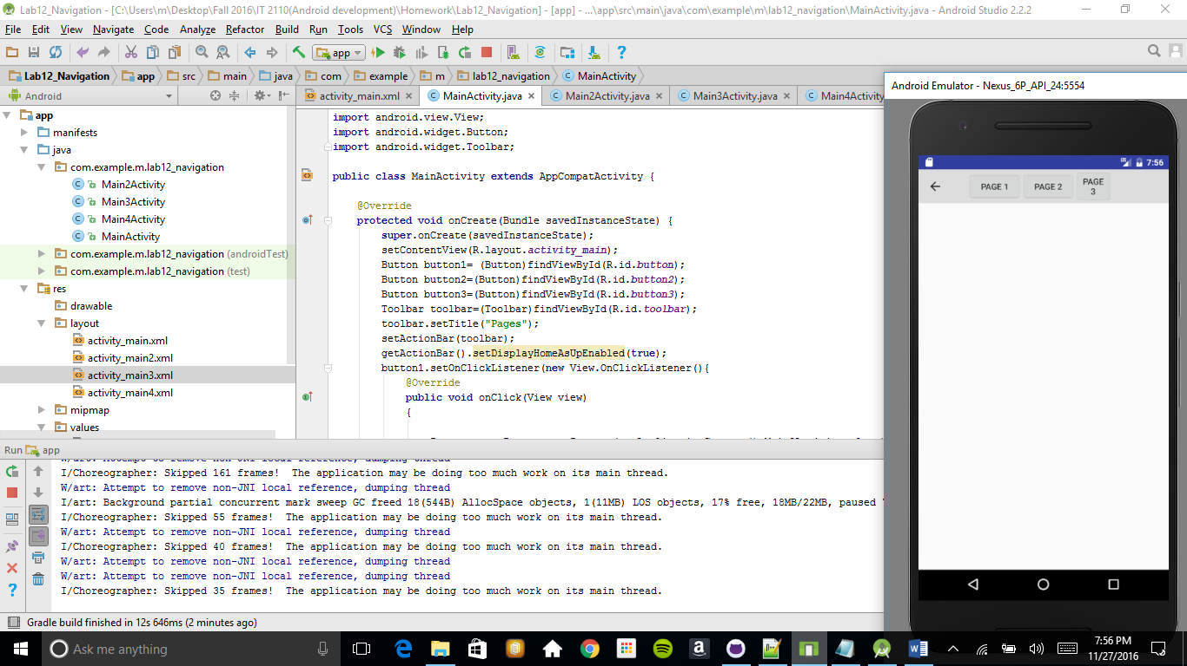

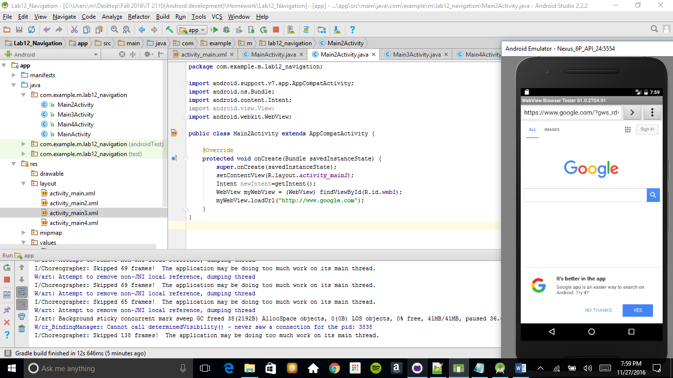

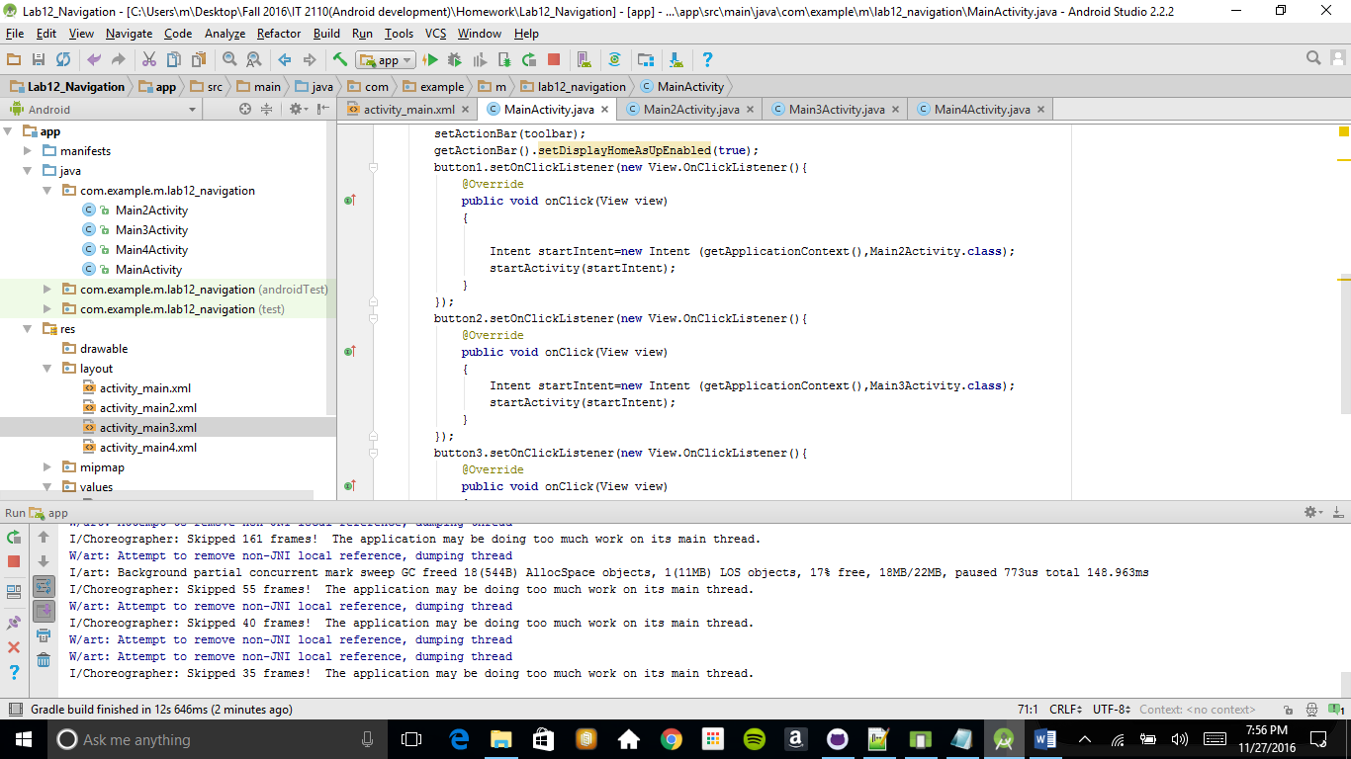

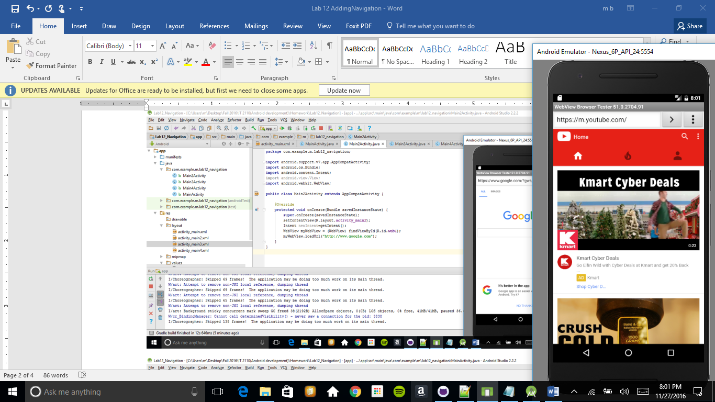

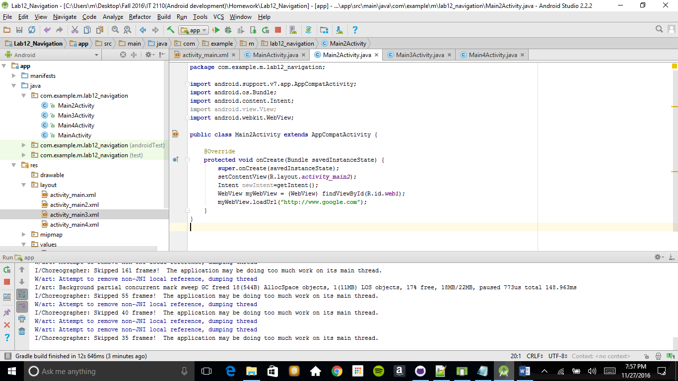

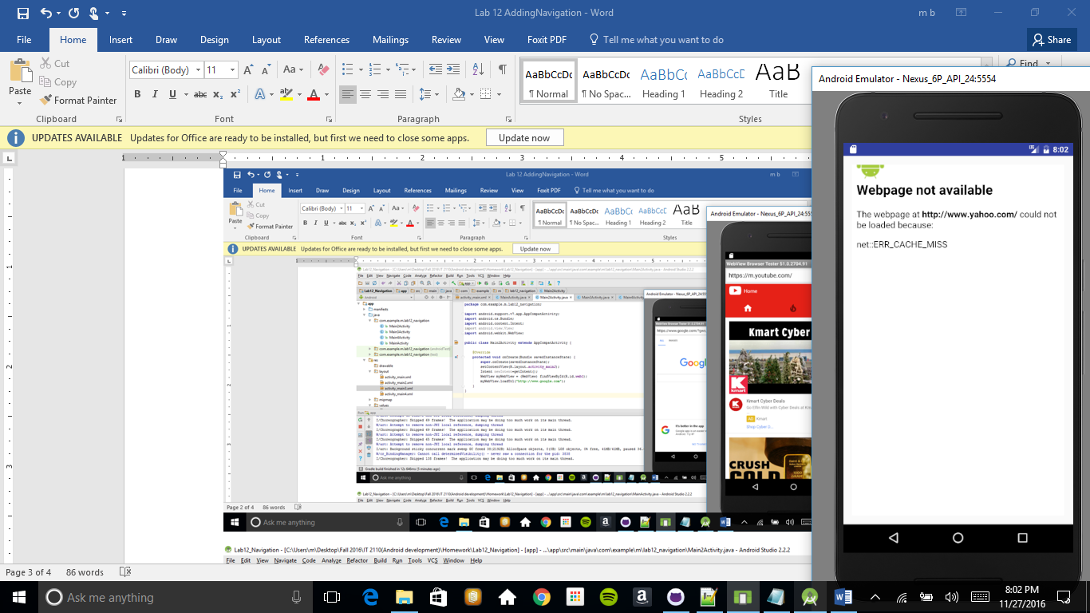

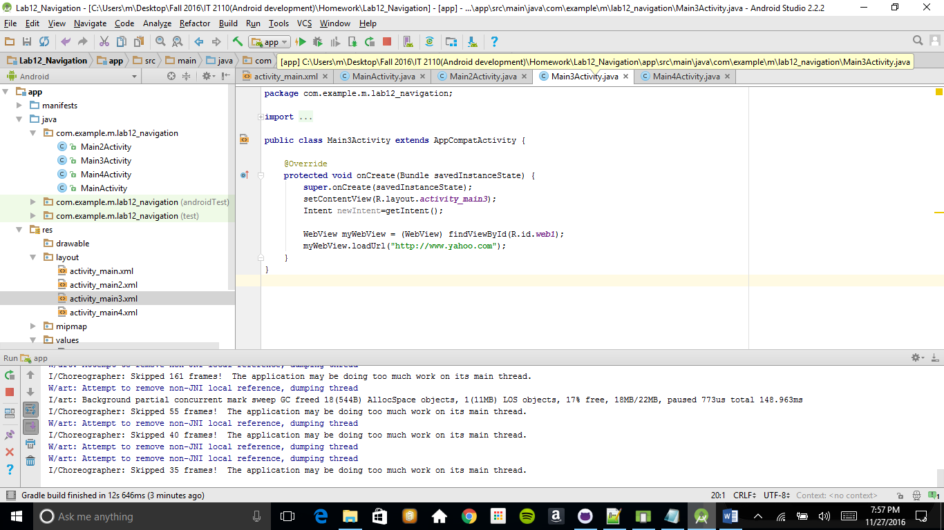

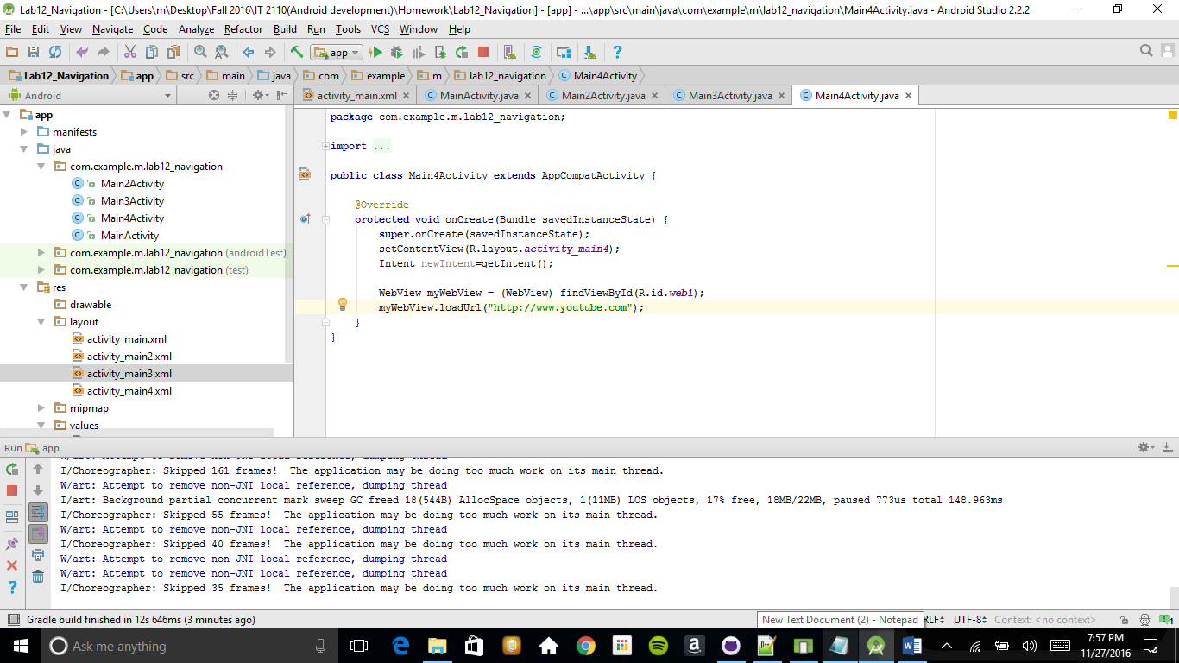

I decided to use a simple toolbar because it can be used as a widget and it means it is easier to customize its look I added 3 buttons and each button had assigned a web page

Problem that I had was with the yahoo page that gave me an error

Another problem was with material from the book ,everything was described to vague and it was not clear were are all filles located